Installing Anaconda
The Anaconda Scientific Python distribution from Continuum analytics is a nice way to install python on any computer. Anaconda makes it easier to install dependencies and it is avalible for free. The the whole installation is located in a folder in the user's directory in a folder that is easily removable. Anaconda is available for the Microsoft Windows, MacOSX and Linux platforms.

Anaconda installation
Go to the website of Anaconda (Fig 1). Download the Anaconda installation file for your operating system and follow the installation instructions and select default options whenever applicable.
Fig 1: Anaconda download site
The installation file is large, but files are only installed in one directory in the users private folder.

Installation on Microsoft Windows
Double click the installer to launch

Installation on MacOSX
Double-click the downloaded file and click continue to start the installation

Installation on Linux
Type: bash Anaconda3-2021.05-Linux-x86_64.sh

If you have any trouble with this step, check the detailed instructions here.
When you have installed Anaconda, the next step is to start the Anaconda Navigator. How to do this may differ between platforms. The MacOSX installer leaves a green Anaconda shortcut on the desktop (Fig 2).
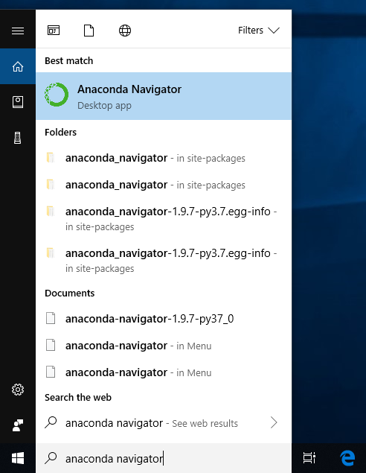Fig 2: The Anaconda Launcher icon is placed on the MacOSX desktop in the upper left corner.
Anaconda Navigator looks like in Fig 3
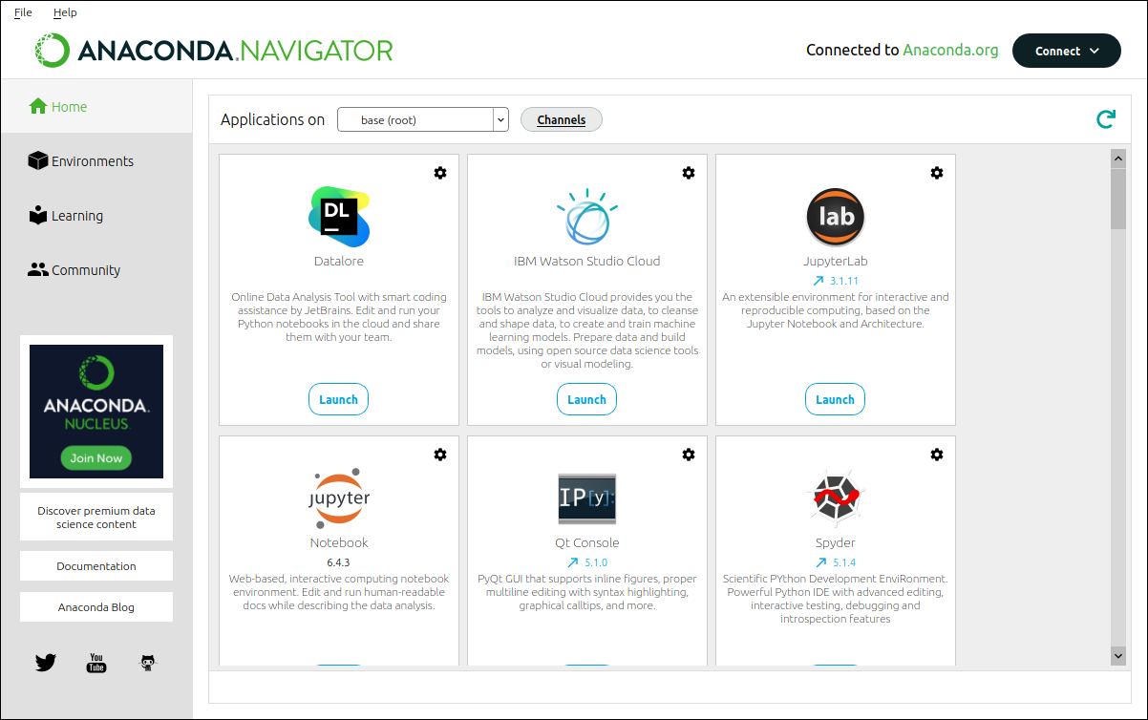Fig 3

Adding a software channel
It is necessary the tell Anaconda where to find useful software. We can do this by adding a software channel to Launcher. Click on the “Channels” link in the upper right corner of the window (Fig 3). Add the channel “BjornFJohansson” as shown in Fig 4 and press return.
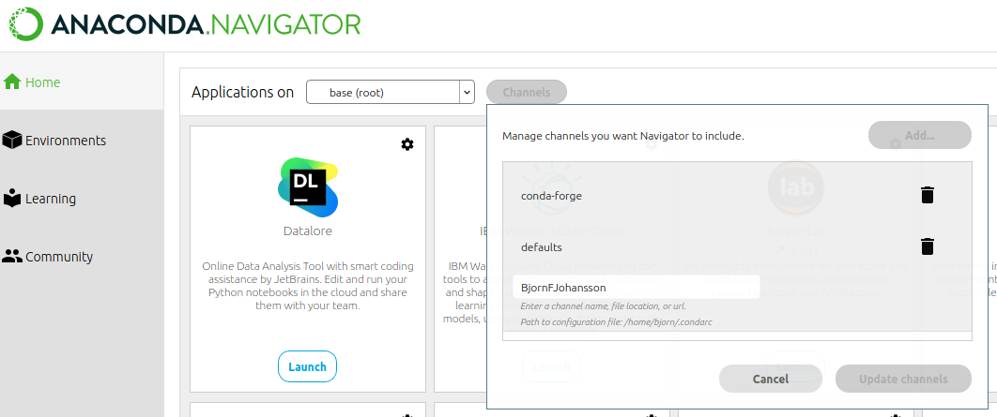Fig 4: Adding the Anaconda software channel BjornFJohansson

When The “conda-forge” channel may not be present on your computer. It is probably not needed. The important thing is that the BjornFJohansson channel is at the end.

Install the pydna python package
Follow the five steps in Fig 5:
1 Activate the “Environments” tab
2 Select “all”
3 type “pydna” in the text box
4 Click the checkbox
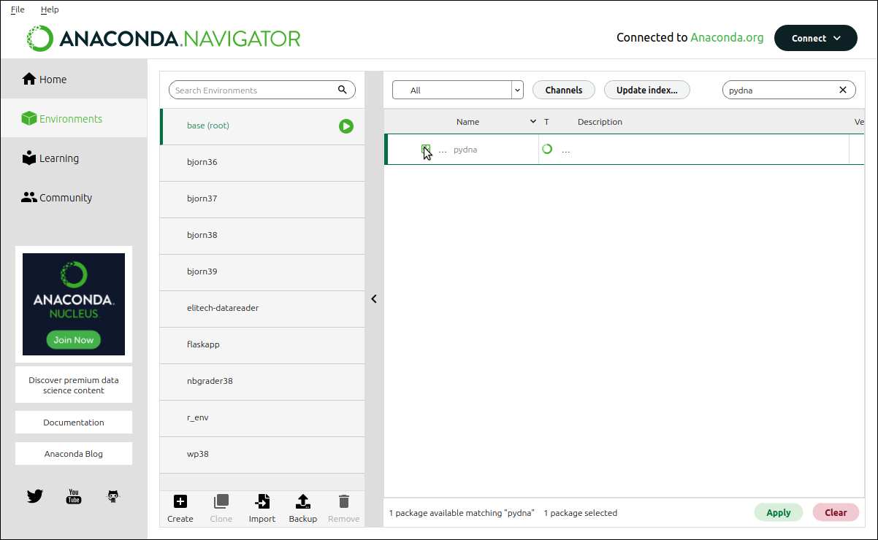





5 Click “Apply”
Fig 5: Sequence of modifications to install a python package

Verify installation
Start “Spyder” from the start menu of your computer.
Type:
import pydna ⮠
pydna.__version__⮠
As indicated in Fig 6 (⮠ = return key).

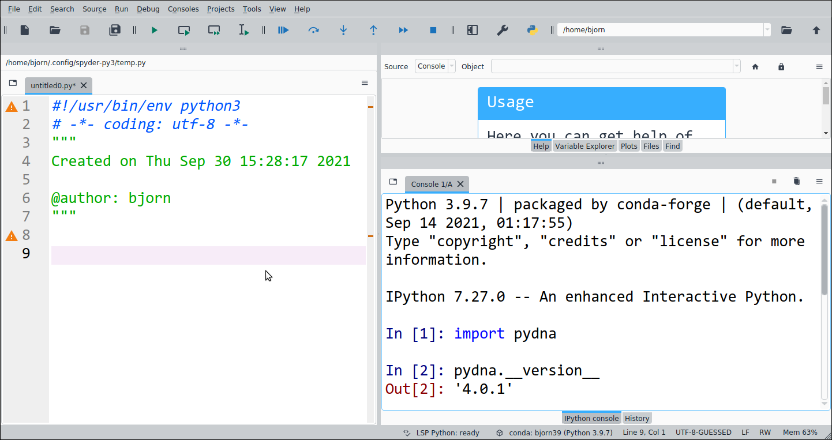Fig 6: Spyder with pydna installed.

